- \Operation\Transfer Swivel Arm\Transfer Swivel Arm (page 1 of 2)
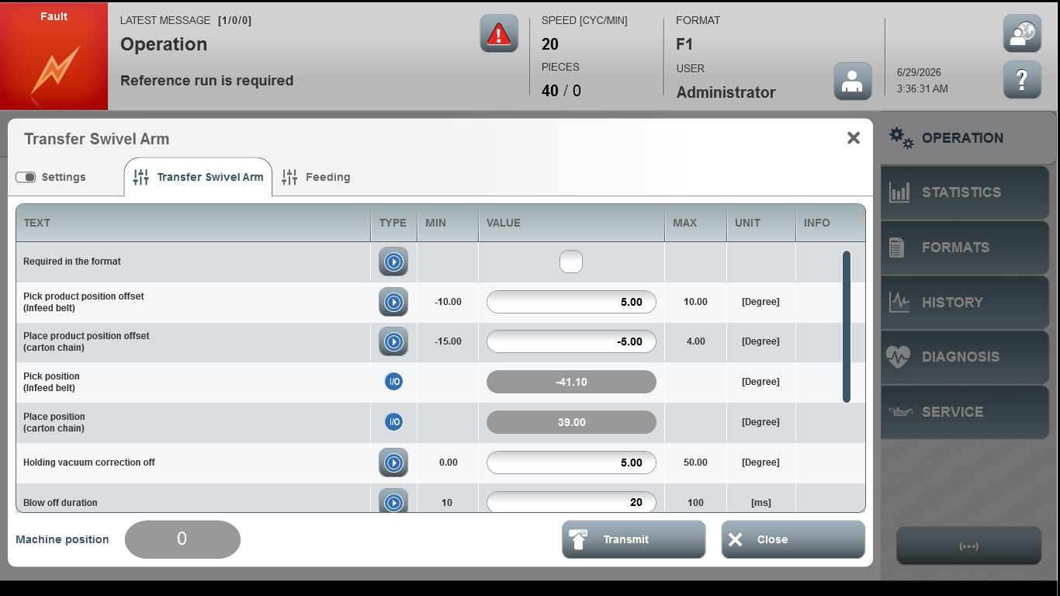
Acceptance criterion | Limits | Pass / Fail: Dev-No. | Date | Initials
Screen matches screenshot | N / A
Pick product position offset (carton belt) | -10.00 … 10.00
Place product position offset (carton chain) | -15.00 … 4.00
Holding vacuum correction off | 1.0 … 50.00
Blow off duration | 10… 100

- \Operation\Transfer Swivel Arm\Transfer Swivel Arm (page 2 of 2)
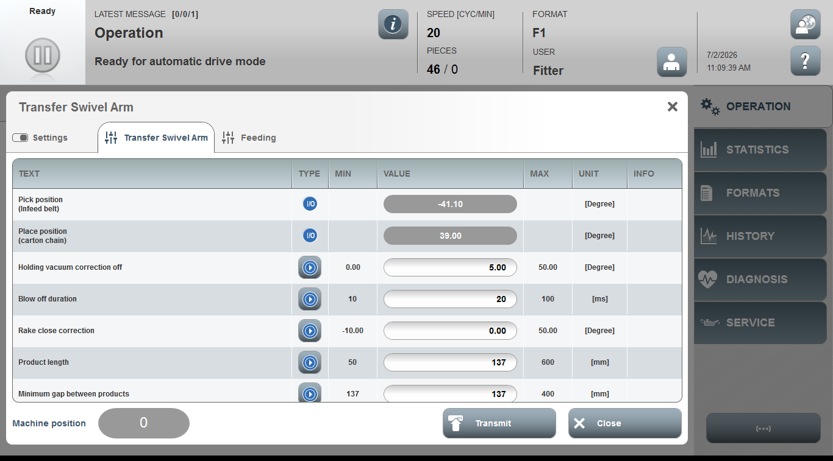
Acceptance criterion | Limits | Pass / Fail: Dev-No. | Date | Initials
Screen matches screenshot | N / A
Rake close correction | -10.00 … 50.00
Product length | 50 … 600
Minimum gab between  products | 137 … 400

